

**COMSATS UNIVERSITY**

**ISLMABAD, ATTOCK CAMPUS**

**NAME: MEHRBAN ALI**

**REG NO: FA20-BCS-065**

**SECTION: BCS 7A**

**SUBJECT: Compiler Construction**

**SUBM TO: Mr.Bilal Haider DATE: 26-10-2023**

**CC MID LAB**

**Question 1**

**Describe functioning of regex C# library , give examples of patterns,seperators and anchors e.t.c.**

The .NET framework in C# provides robust support for regular expressions through the

System.Text.RegularExpressions namespace. Regular expressions, often referred to as regex, allow you to search, match, and manipulate text using patterns. Here's an overview of the functionality provided by the .NET Regex library, along with examples of common regex patterns, separators, anchors, and more.

**1) Separators:**

In regex, separators are characters or patterns used to split or tokenize text. You can use separators to break a string into smaller parts, often used for processing structured data.

**Example 1:** Comma Separated Values (CSV):

* Separator: ,
* Input: "apple,banana,cherry"
* Result: ["apple", "banana", "cherry"]

**Example 2**: Space Separated Words:

* Separator: \s+ (one or more whitespace characters)
* Input: "Hello World Today"
* Result: ["Hello", "World", "Today"]

**Example 3:** Pipe-Delimited Data:

* Separator: \|
* Input: "Alice|Bob|Carol"
* Result: ["Alice", "Bob", "Carol"]

**2) Patterns:**

Regex patterns define rules for matching text. They are used to find or extract specific substrings in a text based on a set of criteria.

**Example 1:** Matching Email Addresses:

* Pattern: [a-zA-Z0-9._%+-]+@[a-zA-Z0-9.-]+\.[a-zA-Z]{2,4}
* Input: "john.doe@example.com"
* Result: john.doe@example.com

**Example 2**: Matching Dates in MM/DD/YYYY Format:

* Pattern: ^(0[1-9]|1[0-2])/(0[1-9]|[12][0-9]|3[01])/\d{4}$
* Input: "02/15/2023"
* Result: "02/15/2023"

**Example 3**: Matching HTML Tags:

* Pattern: <[^>]+>
* Input: <p>This is a <strong>sample</strong> text.</p> • Result: ["<p>", "<strong>", "</strong>", "</p>"]

**3) Anchors:**

Anchors are used to specify the position of the pattern within the text. Common anchors include ^ and $.

**Example 1:** Matching the Start of a Line

* string pattern = "^Start";
* This pattern matches "Start" only if it appears at the start of a line.

**Example 2**: Matching the End of a Line

* string pattern = "End$";
* This pattern matches "End" only if it appears at the end of a line.

**Example 3**: Matching Whole Words

* string pattern = @"\bWord\b";
* The \b anchors match "Word" as a whole word, not as part of a larger word.

**Question 2:**

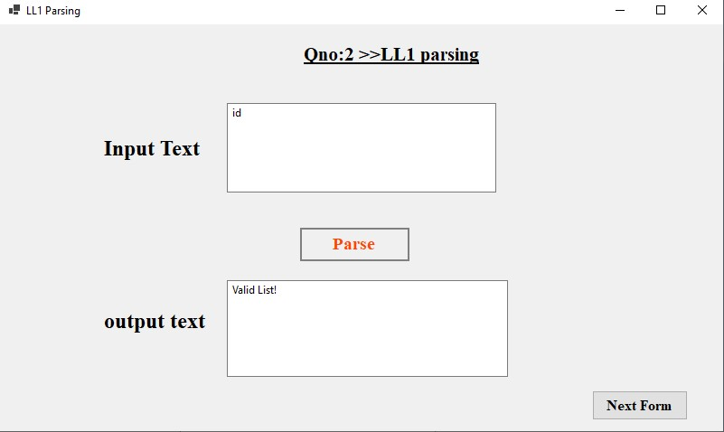

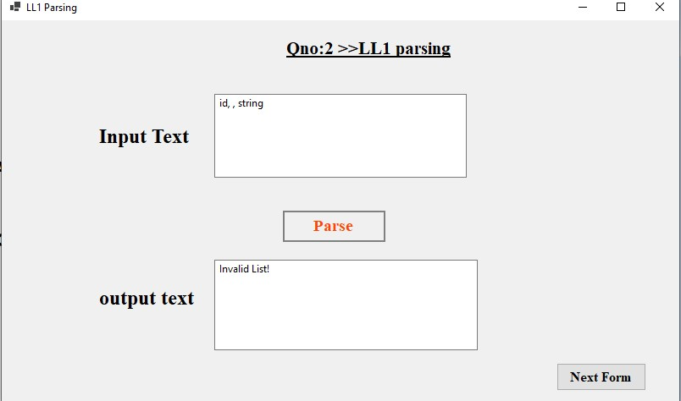

**Question 3:**

